ITA0305- Mobile Computing
LAB EXPERIMENT
Name: G.Ganesh
Reg NO:192373008

6) Use Figma to simulate a handoff scenario in a mobile network and visualize the
process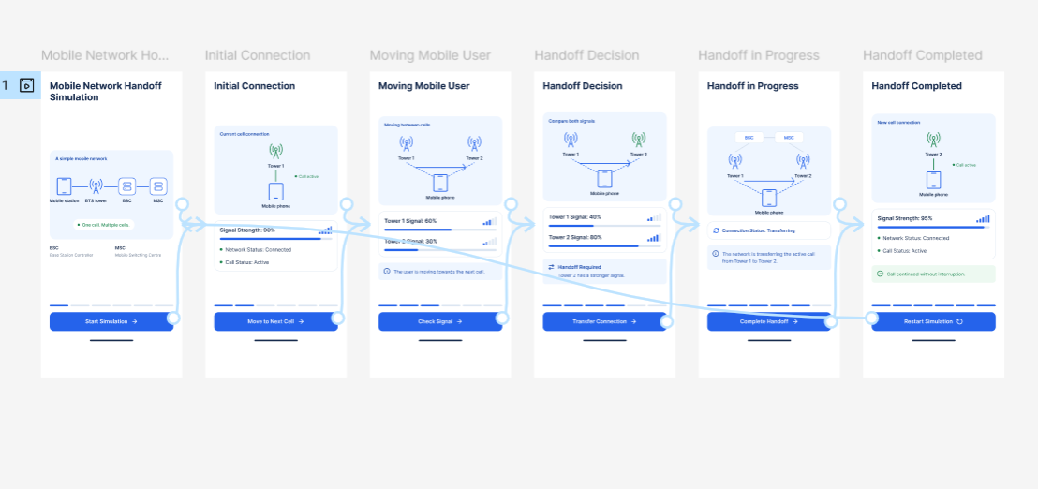
https://www.figma.com/design/YvlSqf2pelkYhGiSjotRCJ/program06?node-id=0-1&p=f&t=tD3c8Yd4CqvzCUpJ-0

